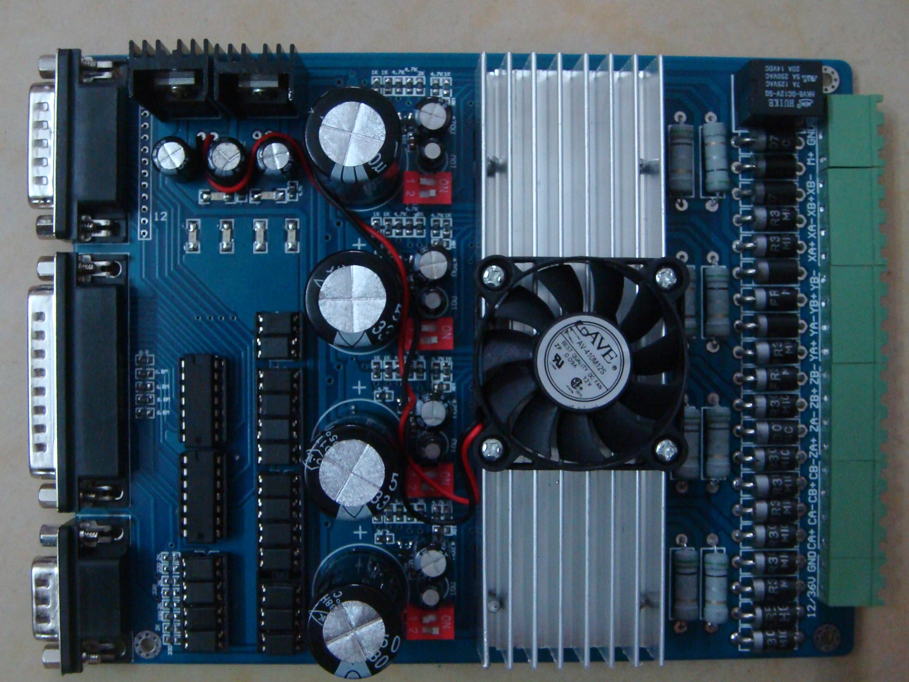
The definition of 1-PIN 15 of Parallel Interface is described as follows:
PIN16 | PIN1 | PIN4 | PIN14 | PIN7 | PIN17 | PIN2 | PIN6 | PIN8 | PIN3 | PIN6 | PIN9 | PIN5
spindle motor | A Empower | A  Dir | A  Step | B  Empower | B  Dir | B  Step | C  Empower | C  Dir | C  Step | D  Empower | D  Dir | D  Step

The definition of 1-PIN15 of Manual Interface is described as follows:
P1 | P2 | P3 | P4 | P5 | P6 | P7 | P8 | P9 | P10 | P11 | P12 | P13 | P14 | P15
A Empower | C  Dir | D  Dir | C  Step | B  Empower | B  Dir | A  Dir | D  Empower | A  Step | C  Empower | B  Step | D  Step | GND | GND | 5V  VDD

Please connect the power supply to the power switch of 12-24 V, 5A and above as shown in the figure.
The power output of 12 V shall be applied to the radiator fan of 12V.
The voltage of the spindle motor must comply with the scope of the supply voltage.
The interface of stepper motor shall be connected with 2-phase-and-4-wire/6-wire stepper motor (Model 42-57) within 2A current.

P1 | P2 | P3 | P4 | P5 | P6 | P7 | P8 | P9 | P10 | P11 | P12 | P13 | P14 | P15 | P16
12-24v | GND | GND |  | ZA+ | ZA- | ZB+ | ZB- | YA+ | YA- | YB+ | YB- | XA+ | XA- | XB+ | XB-

Instructions of MACH
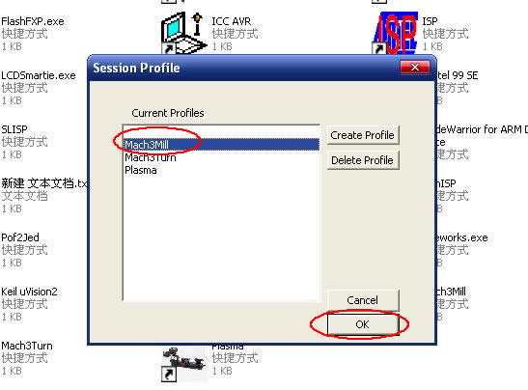
图1
Open MACH3 software, select mach3MILL, and then click OK. Please refer to Fig.1
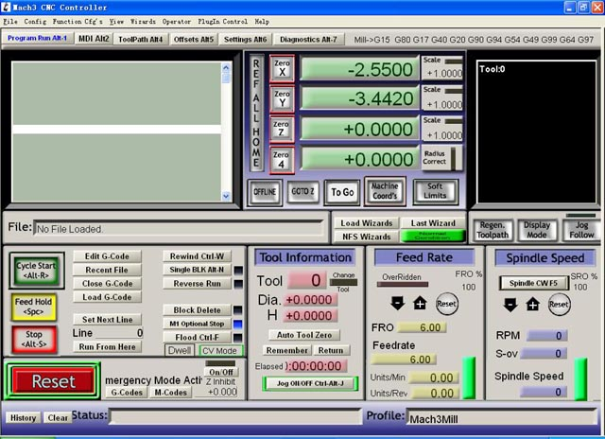
图2

The interface of MACH3 is displayed as Fig.2. The frequently-used action buttons are listed on the interface. We can configure MACH software at first.
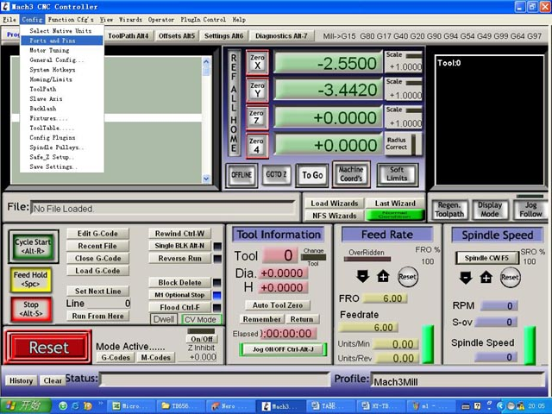。
图3
Click PORT & PIN sub-menu of config menu. Please refer to Fig.3.
Please refer to Fig.4
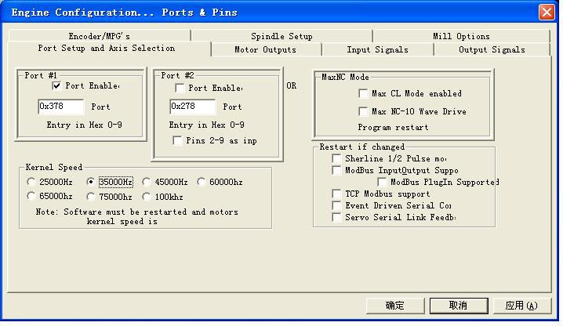
图4

To set up the basic frequency within the above Circle 1. This parameter will affect the rotational speed of the motor. After the setup of basic frequency, select Circle 2 where Configuration Scripting will be defined, please refer to Fig.5.
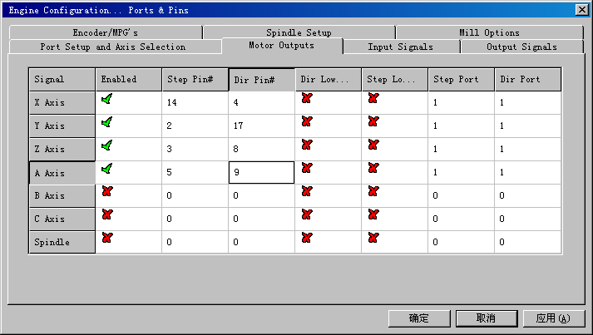

图5

To modify the software settings according to the definition of Parallel Interface which is detailed in the above circle.
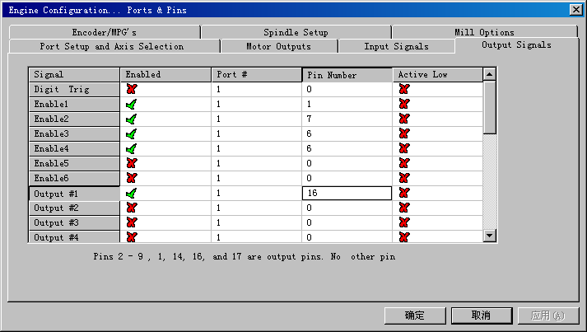
图6
Then select the output signals column, as shown in Fig.6, and set up the corresponding items per the setup described in the circle.
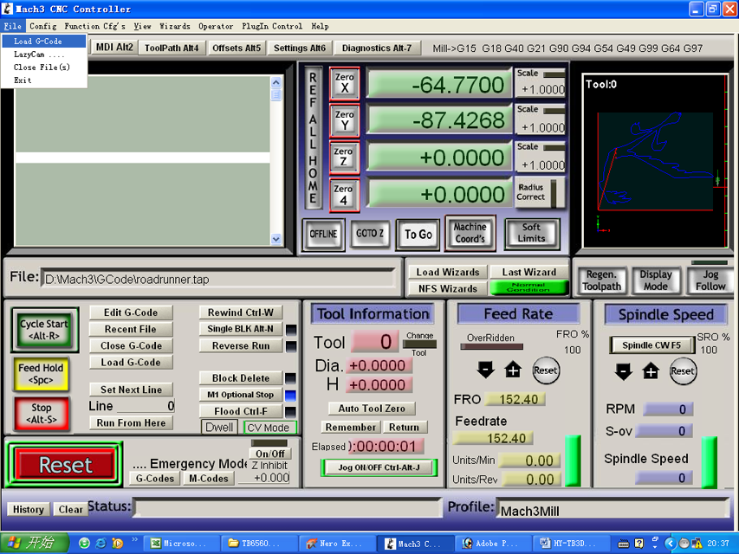
图7
After all have been set up, open the G CODE that needs to run, as shown in Fig.7
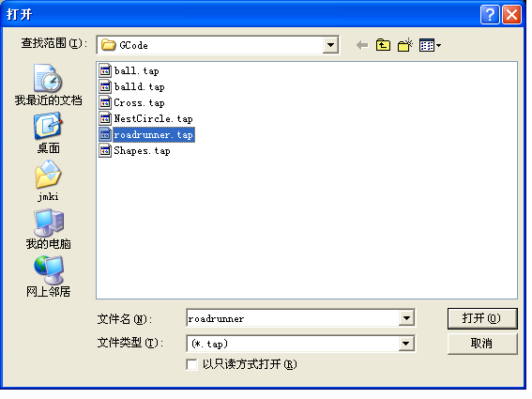
图8

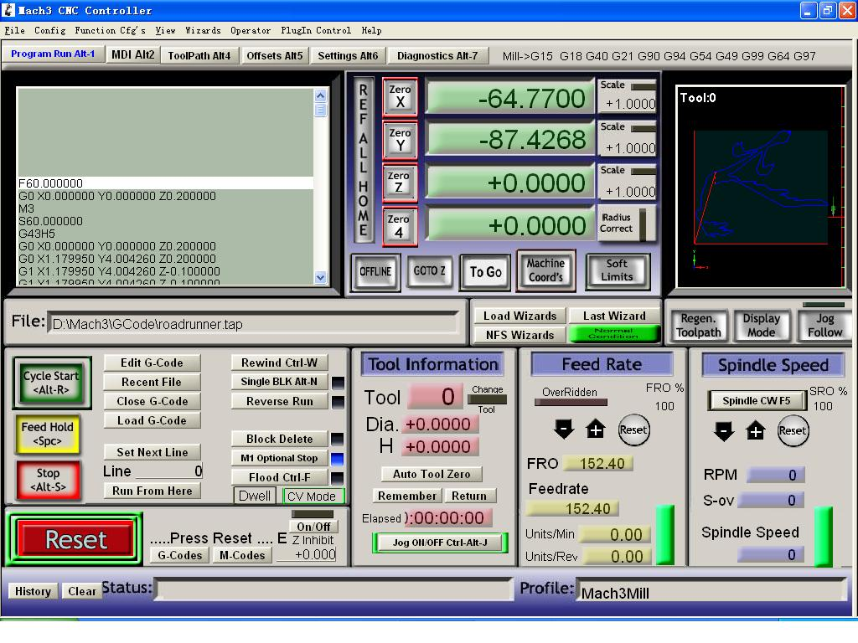
图9
After G CODE has been opened, you may see the red button RESET flashing. Click RESET to stop the flashing and then press CYCLESTART at the location of Circle 2。

Note: If you press TAB on the keyboard, a manual test panel will be displayed.
The limit interface shall be connected with three-axis limit switch. The setting shall be done in output signals column.

