Manual Control Manual
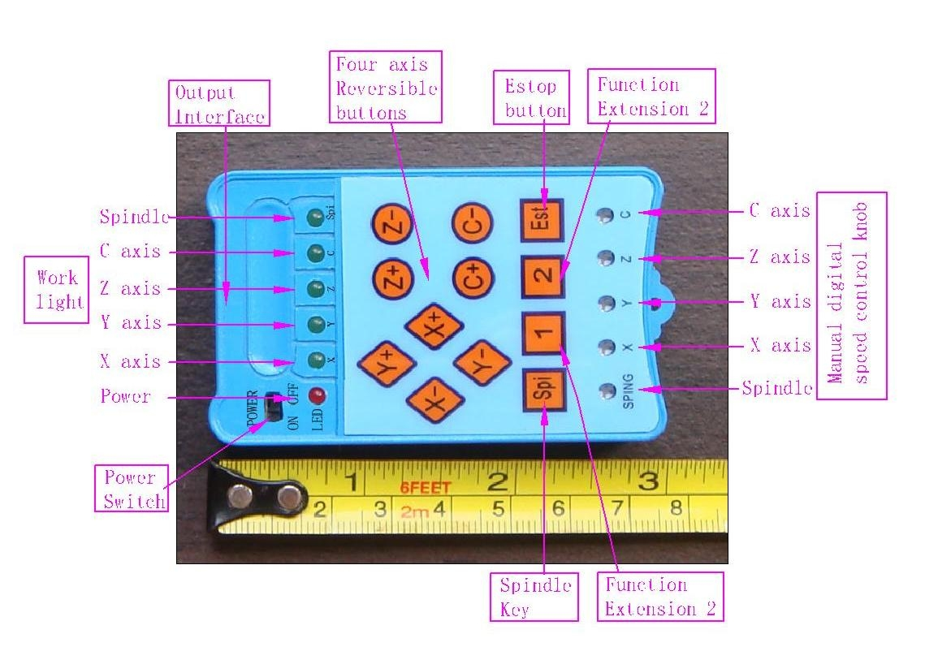
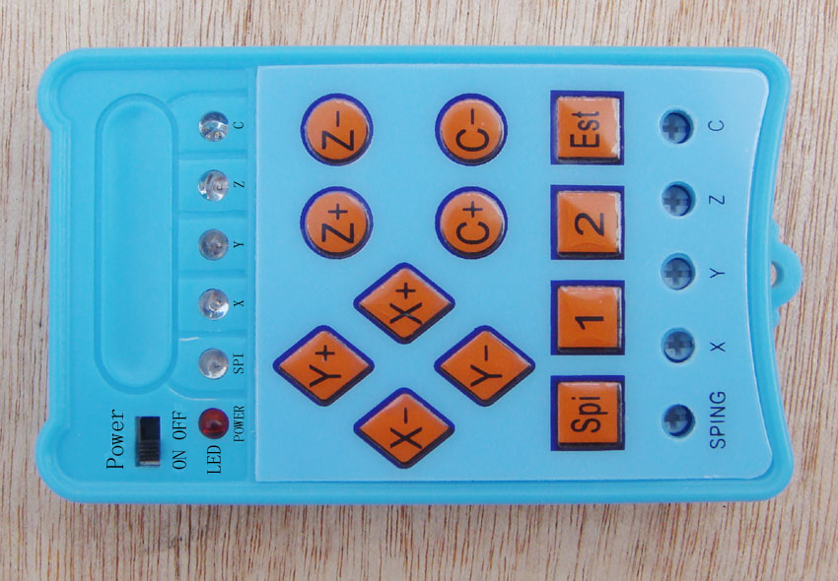
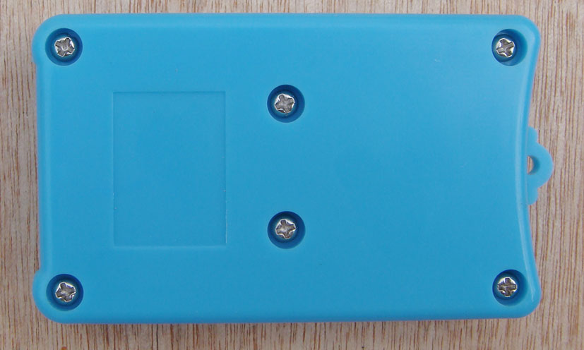
一》15P connector at both ends of the corresponding Definitions

1 | 2 | 3 | 4 | 5 | 6 | 7 | 8 | 9 | 10 | 11 | 12 | 13 | 14 | 15
Black | Palm | Red | Orange | Yellow | Green | Blue | Purple | Gray | White | Powder | Light green | Black/White | Palm/White | Red/White

二》Handle the output interface definition
1 | 2 | 3 | 4 | 5 | 6 | 7 | 8 | 9 | 10 | 11 | 12 | 13 | 14
5V/VDD | GND | Estop | Empower1 | Empower2 | Spindle | X/Dir | X/Step | Y/Dir | Y/Step | Z/Dir | Z/Step | C/Dir | C/Step

二》HY-TB3DV-M axis drive board manual interface definition
Black | Palm | Red | Orange | Yellow | Green | Blue | Purple | Gray | White | Powder | Light green | Black/White | Palm/White | Red/White
P1 | P2 | P3 | P4 | P5 | P6 | P7 | P8 | P9 | P10 | P11 | P12 | P13 | P14 | P15
X/Step | X/Empower | Spindle | X/Dir | Y/Empower | Z/Dir | Z/Step | Z/Empower | 5V/VDD | GND | Estop | Y/Step | Y/Dir | Z/Limit | Y/Limit

三》HY-TB4DV-M four-axis drive board manual interface definition

Black | Palm | Red | Orange | Yellow | Green | Blue | Purple | Gray | White | Powder | Light green | Black/White | Palm/White | Red/White
P1 | P2 | P3 | P4 | P5 | P6 | P7 | P8 | P9 | P10 | P11 | P12 | P13 | P14 | P15
Z/CEmpower | C/Step | Z/Step | X/Dir | X/Empower | Y/Empower | Y/Dir | Z/ Dir | 5V/VDD | GND | Estop | X/Step | Y/Step | Spindle | C/Dir

四》HY-TB5DV-M axis drive board manual interface definition
Black | Palm | Red | Orange | Yellow | Green | Blue | Purple | Gray | White | Powder | Light green | Black/White | Palm/White | Red/White
P1 | P2 | P3 | P4 | P5 | P6 | P7 | P8 | P9 | P10 | P11 | P12 | P13 | P14 | P15
总Empower | C/Step | Z/Step | X/Step | X/Dir | Y/Dir | Z/Dir | C/Dir | 5V/VDD | GND | Estop | Y/Step | D/Step | Spindle | DDir

TA4 handle axis defined
Black | Palm | Red | Orange | Yellow | Green | Blue | Purple | Gray | White | Powder | Light green | Black/White | Palm/White | Red/White
P1 | P2 | P3 | P4 | P5 | P6 | P7 | P8 | P9 | P10 | P11 | P12 | P13 | P14 | P15
Spindle | A/Dir | B/Dir | B/ Empower | C/Step | D/Dir | C/Dir | A/ Empower | 5V/VDD | GND | GND | D/Step | B/Step | C/允许 | A/Step
Interface board handles the definition of
Black | Palm | Red | Orange | Yellow | Green | Blue | Purple | Gray | White | Powder | Light green | Black/White | Palm/White | Red/White
P1 | P2 | P3 | P4 | P5 | P6 | P7 | P8 | P9 | P10 | P11 | P12 | P13 | P14 | P15
C/Dir | C/ Step | X/ Step | X/Dir | Y/Dir | Z/Dir | Spindle | Expand | 5V/VDD | GND | Estop | Y/ Step | Z/ Step | E1 | E2

Instructions
1: The first drive with a corresponding docking connector board good driver board
2: turn on the power switch, power indicator light
3: Click the corresponding axis manual control buttons, the corresponding stepper motor shaft rotation axis while the corresponding indicator light, release the button to stop stepping motor
4: Manually adjust the speed dial number is about 300 degrees rotation within the (limited spaces on both sides of the fixed position), clockwise rotation acceleration, deceleration counterclockwise rotation，
