HY-CLX-S four-axis stepper motor control box instructions
Thank you for choosing our products, Better and faster for you to use NC products Please read this manual
Features:Features
1: Up to 4 sets of 42-86 then type stepping motor, 2-phase, 4 phase, 4 wire 6, line 8 line 3.5A current for the stepper motor
2: two-stage signal processing, signal transmission smooth, powerful anti-jamming
3：5 emergency stop input interface to define, limit, points in the knife, etc.
4: Relay output control interface, can be accessed by the spindle motor or the air pump, water pump, etc.
5：Axis manual speed control speed control and dual-function computer, through the selection switch
6: Four-axis work light display, visual display products, working condition.
7：Manually adjust the spindle speed control speed control and dual-function computer
8：Dual power selection interface, emergency stop button
Electrical performance (Tj = 25 ℃ ambient temperature when):
Input Power | 24 DC power supply or external power adapter
Work axis stepper | Then the maximum current of 3.5A Step 4
Drive | Pulse + direction + enable signal.
Weight | About 2,000 grams.
Interface definition table:
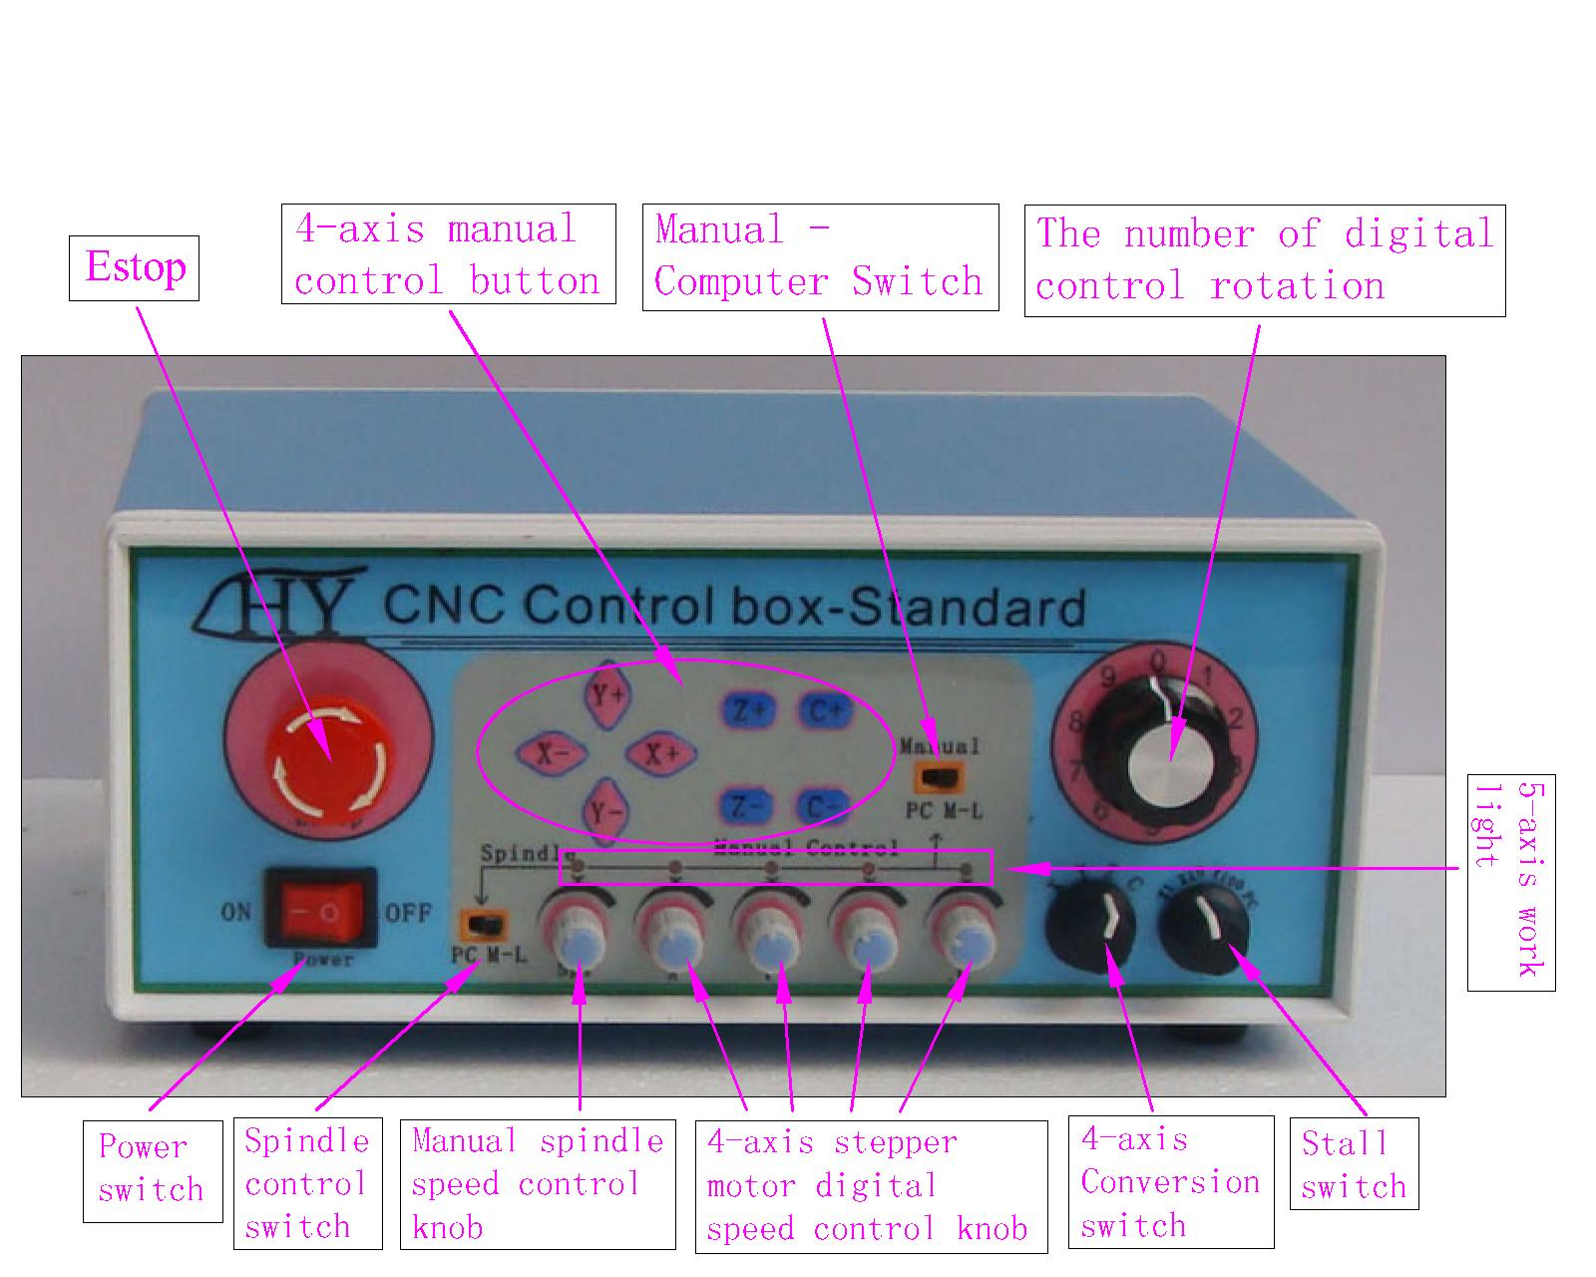
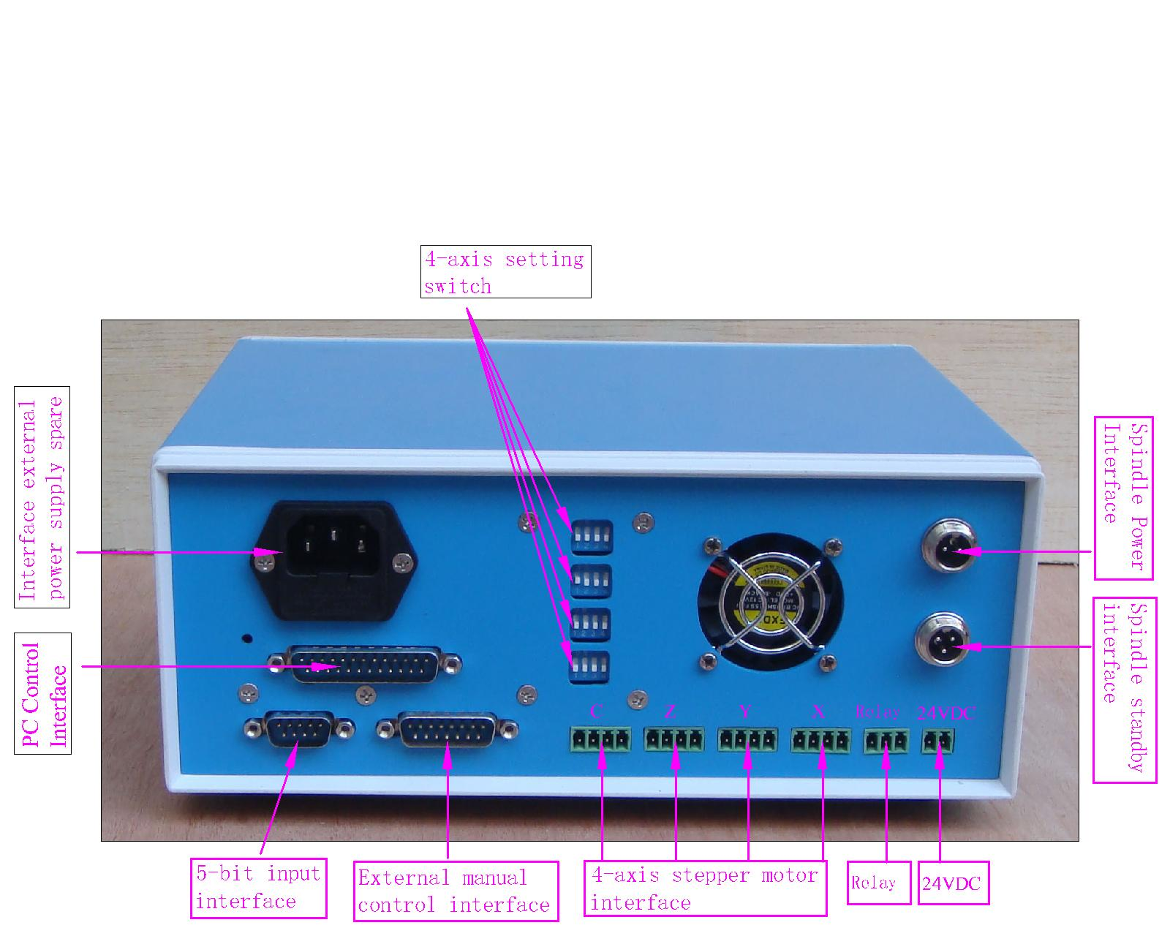
Waveform and timing
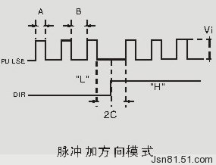
Power output interface function
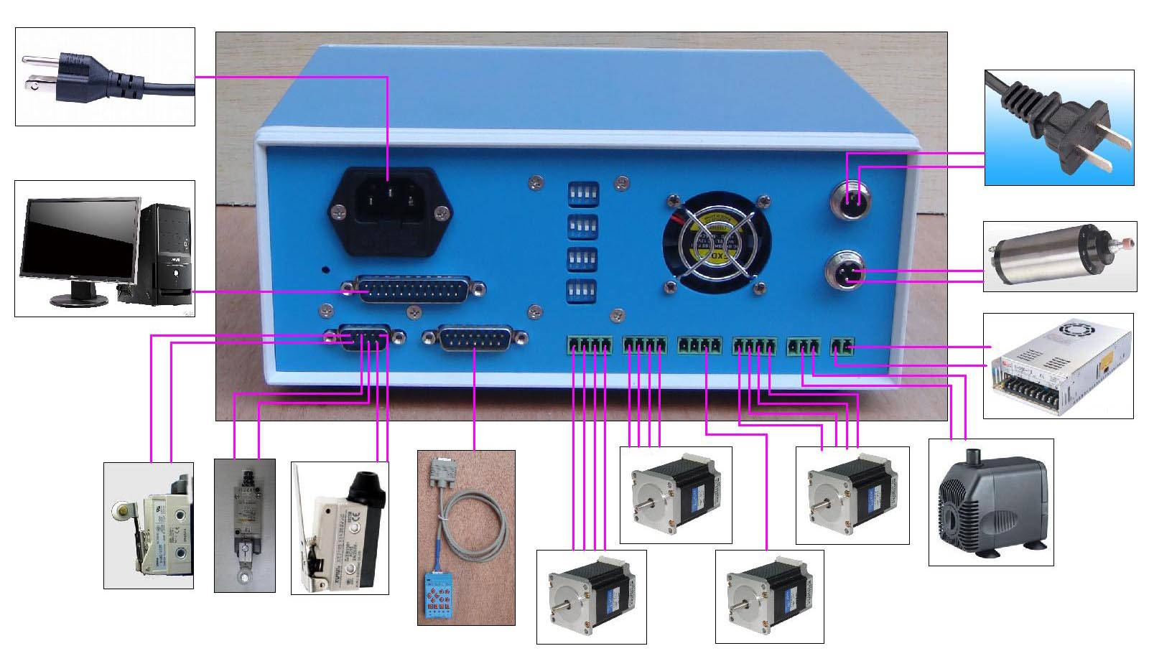
Interface, detailed drawing marked
In the test machine, note the following before
1、Note that using the 24V DC power supply
2、Stepper drives work OK (model)
3、Stepper drive connection to determine
Second, "the definition of the pin
1 "Parallel Port Control is defined as follows
PIN1 | PIN17 | PIN2 | PIN3 | PIN4 | PIN5 | PIN6 | PIN7 | PIN8 | PIN9 | P14 | P16
继电器 | 总使能 | X  脉冲 | X  方向 | Y  脉冲 | Y  方向 | Z  脉冲 | Z  方向 | A  脉冲 | A  方向 | 主轴 | 扩展

2 "1 ~ PIN15 manual are defined as follows (in computer 15P interfaces and benchmarks within the Digital ID)
P1 | P2 | P3 | P4 | P5 | P6 | P7 | P8 | P9 | P10 | P11 | P12 | P13 | P14 | P15
继电器 | 主轴 | X脉冲 | Y  脉冲 | Z  脉冲 | A  脉冲 | 总使能 | 扩展 | VDD | GND | X方向 | Y  方向 | Z  方向 | A  方向 | 急停

3 "The limit is defined as 1 to 5
X轴限位 | Y轴限位 | Z轴限位 | A轴限位 | 急停
输入1 | 输入2 | 输入3 | 输入4 | 输入5
对应并口P10 | 对应并口P11 | 对应并口P12 | 对应并口P13 | 对应并口P15

5V 1A power supply, please take more than switching power supplies, power input received indicated on the map interface. spindle motor control is controlled via the parallel port PIN1. Spindle motor voltage must comply with the supply voltage range
Three "Control Panel Function
1: Power switch
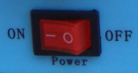 | ON：Open the control box power
 | OFF：Turn off the power control box
2: The spindle control
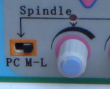 | PC position switch: Spindle speed control for the computer control
 | ML position switch: Spindle speed control for manual control panel, you can adjust the spindle speed spindle speed control knob and switch

3: Step Four-axis Control
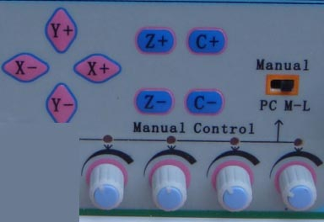 | PC position switch: for the computer-controlled stepper axis state (off panel manual control)
 | ML position switch: Four-axis step manual control for the panel status (open panel manual control), and by the corresponding number of speed control knob shaft speed step operation speed
4: Emergency stop button
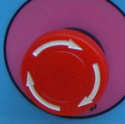 | Emergency stop button: press the emergency stop in the operation, such as keys, all steps to stop running, while lock control function, the lifting of emergency stop control be restored
5 hand-wheel control system
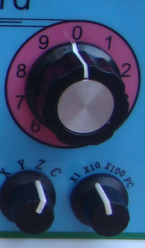 | Axis position control knob: X / Y / Z / A four-axis control switch for single-axis control mode, point-axis for the control of state
 | Stall control knob: Step operation rate, * 1 to 1 ratio, * 10 to 10 ratio
 | Digital control knob: control of step or stepper motor running in degrees, multiplied by the gear ratio control knob

C "MACHSoftware Usage
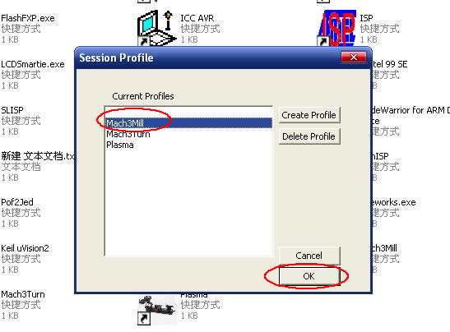
Figure 1
Figure 1 Open the MACH3 softwareThen select OK now mach3MILL

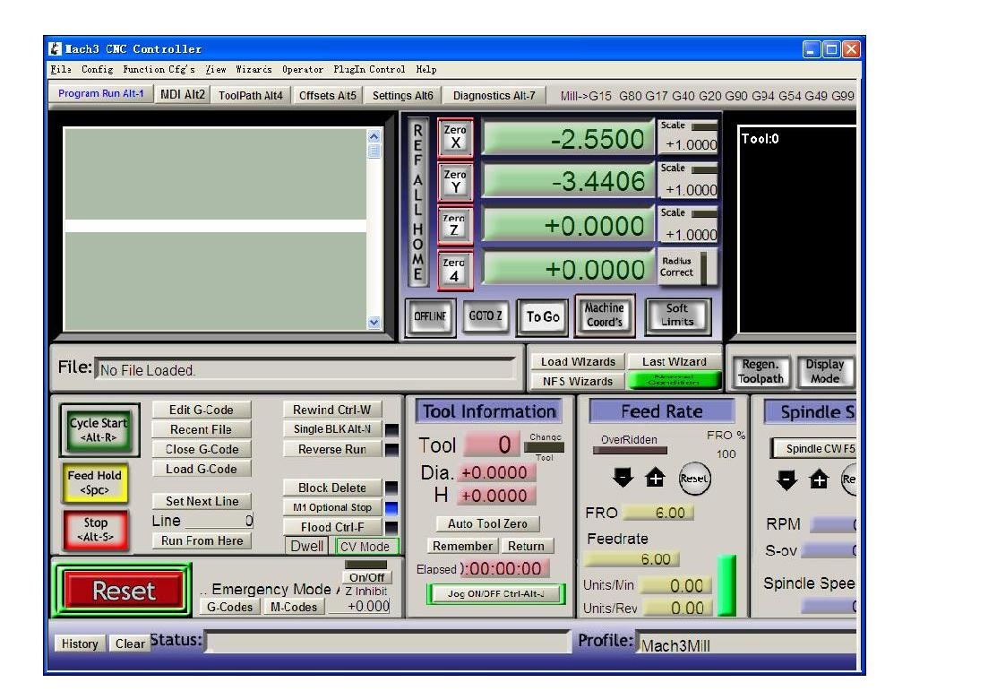
Figure 2

MACH3 open the interface shown in Figure 2, Button above the action of commonly used,Here we configure the MACH software.
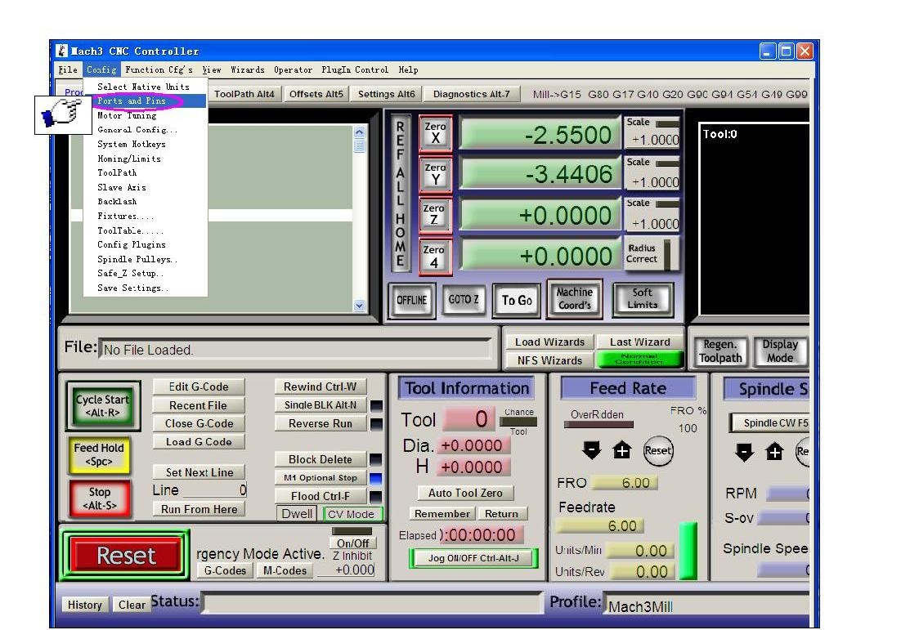
Figure 3
Figure 3 Open the config menu, PORT & PIN menu

Figure4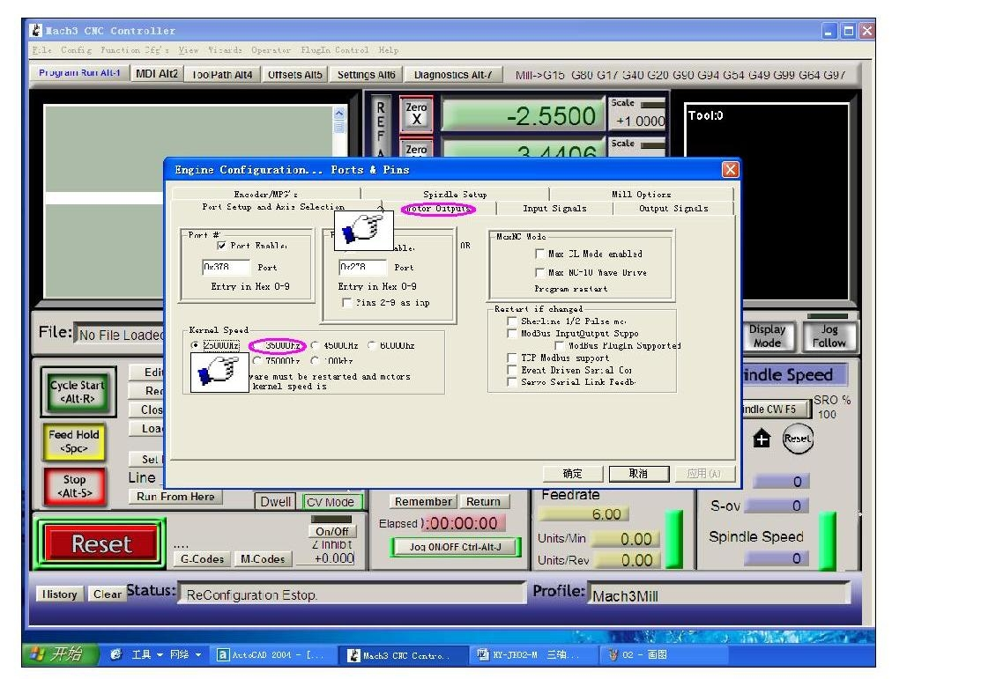
Figure 4
Place on lap 1 setting can set the fundamental frequency, The parameters of the motor rotation speed. 2 set and select circle where Configuration pin definition Figure 5
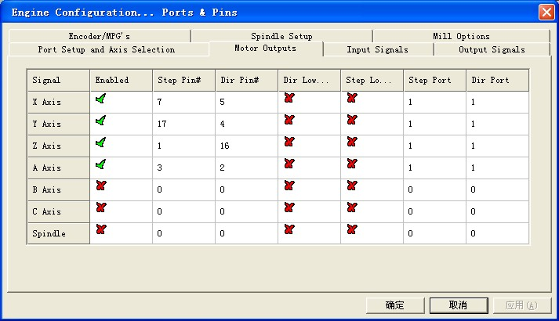

Figure 5
According to the definition of the board parallel port, Follow the circle to indicate the definition of the map to modify the software settings.
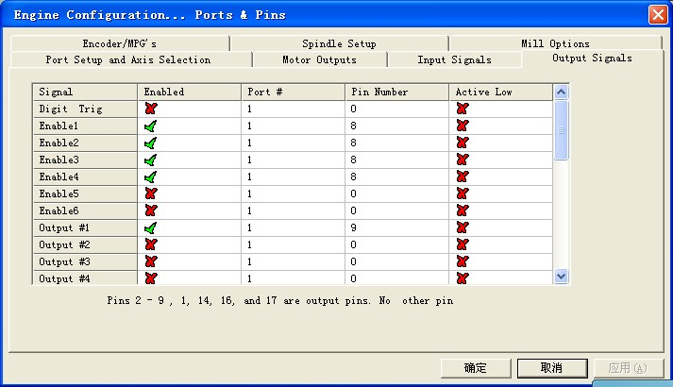

Figure 6
Then select the output signals in the column Figure 6, according to the setting circles, Set the corresponding entry。
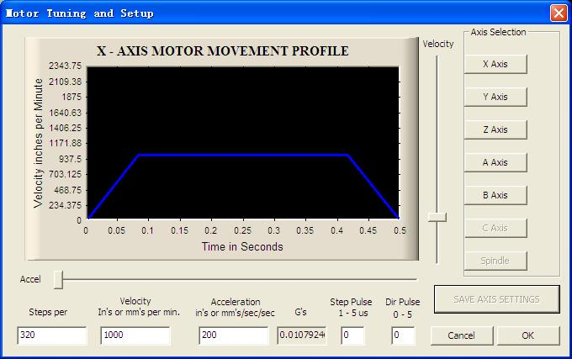
Motor reference set parameters,MACH3 Software manual in detail and description of the formula
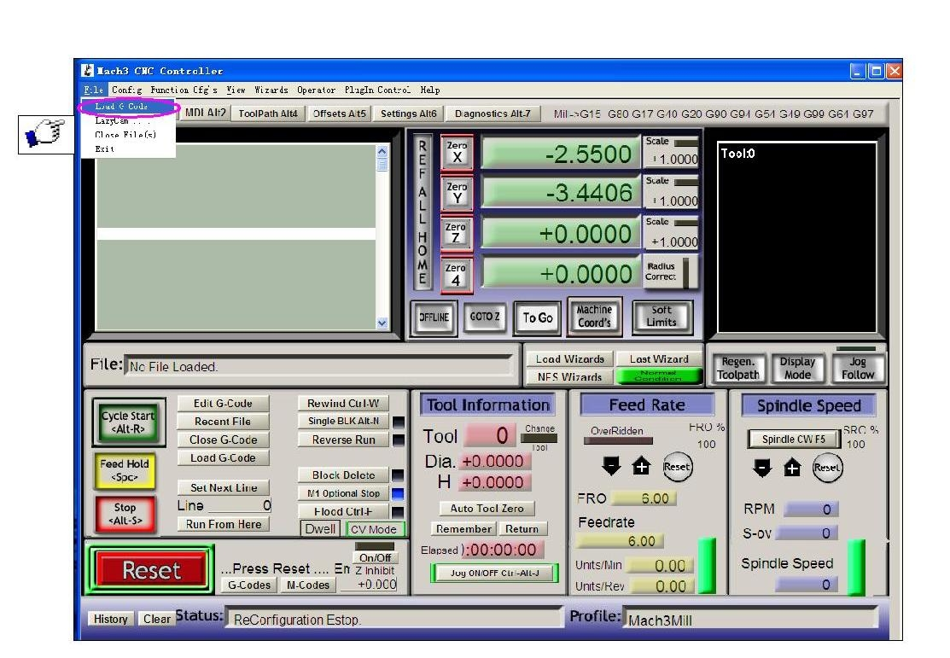
Figure 7
After all the settings ok, G to open the need to run the code, as shown in Figure 7

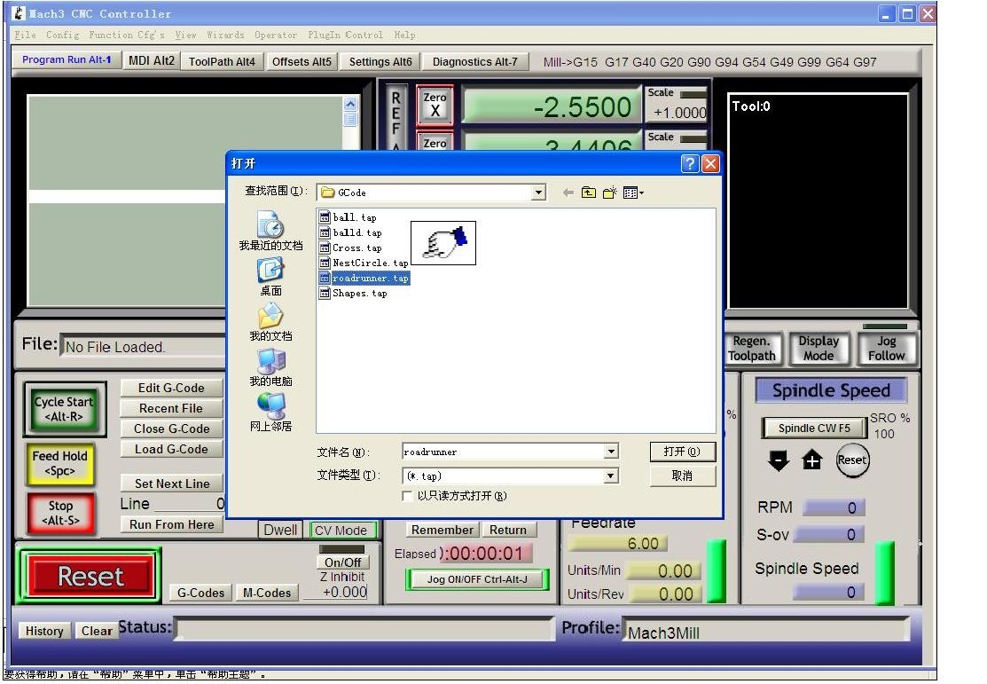
Figure 8

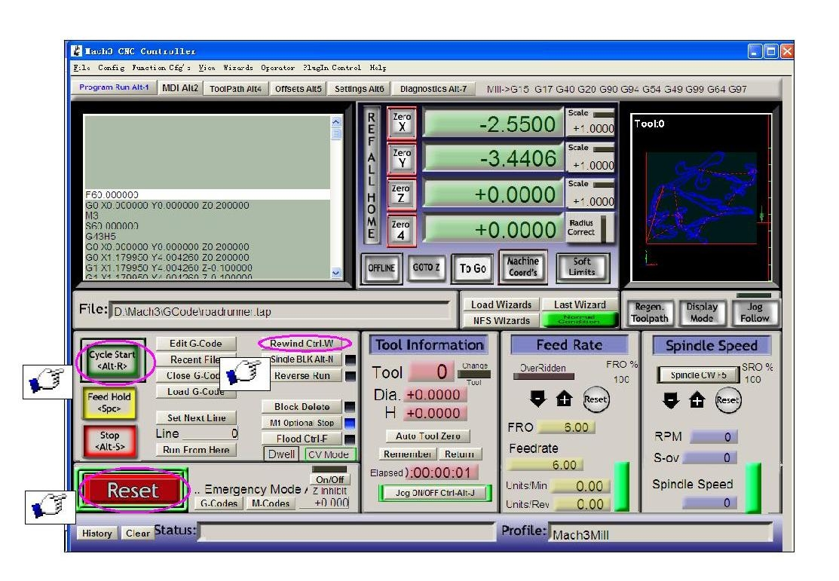
Figure 9
Open the G code, RESET can see the red flashing Can use the mouse click the RESET make it stop flashing, You can then press the ring 2 position CYCLESTART run. Limit supplement，As shown
